Lifecycle Hooks

[Phases](https://codecraft.tv/courses/angular/components/lifecycle-hooks/#_phases)

A component in Angular has a life-cycle, a number of different phases it goes through from birth to death.

We can hook into those different phases to get some pretty fine grained control of our application.

To do this we add some specific methods to our component class which get called during each of these life-cycle phases, we call those methods *hooks*.

The hooks are executed in this order:

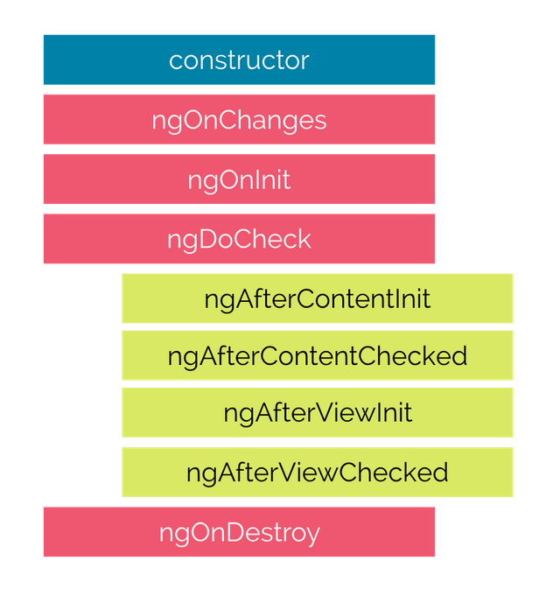

These phases are broadly split up into phases that are linked to the component itself and phases that are linked to the *children* of that component.

[Hooks for the Component](https://codecraft.tv/courses/angular/components/lifecycle-hooks/#_hooks_for_the_component)

**constructor**

This is invoked when Angular creates a component or directive by calling new on the class.

**ngOnChanges**

Invoked **every** time there is a change in one of th *input* properties of the component.

**ngOnInit**

Invoked when given component has been initialized.  
This hook is only called **once** after the first ngOnChanges

**ngDoCheck**

Invoked when the change detector of the given component is invoked. It allows us to implement our own change detection algorithm for the given component.

Important

ngDoCheck and ngOnChanges should not be implemented together on the same component.

**ngOnDestroy**

This method will be invoked just before Angular destroys the component.  
Use this hook to unsubscribe observables and detach event handlers to avoid memory leaks.

[Hooks for the Component’s Children](https://codecraft.tv/courses/angular/components/lifecycle-hooks/#_hooks_for_the_components_children)

These hooks are only called for components and not directives.

**ngAfterContentInit**

Invoked *after* Angular performs any content projection into the component’s view

**ngAfterContentChecked**

Invoked each time the content of the given component has been checked by the change detection mechanism of Angular.

**ngAfterViewInit**

Invoked when the component’s view has been fully initialized.

**ngAfterViewChecked**

Invoked each time the view of the given component has been checked by the change detection mechanism of Angular.

Reference

https://codecraft.tv/courses/angular/components/lifecycle-hooks/